**Objectives**

* Explain the need and Benefits of component life cycle
* Identify various life cycle hook methods
* List the sequence of steps in rendering a component

In this hands-on lab, you will learn how to:

* Implement componentDidMount() hook
* Implementing componentDidCatch() life cycle hook.

## **Prerequisites**

The following is required to complete this hands-on lab:

* Node.js
* NPM
* Visual Studio Code

## **Notes**

Estimated time to complete this lab: **60 minutes.**

1. Create a new react application using *create-react-app* tool with the name as “blogapp”
2. Open the application using VS Code
3. Create a new file named as **Post.js** in **src folder** with following properties

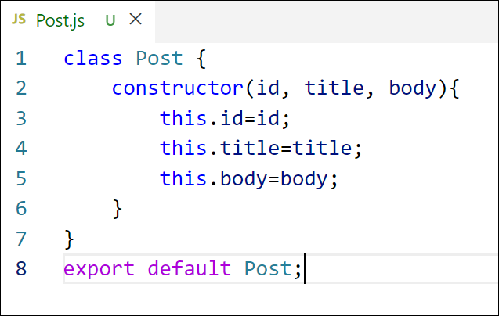

Figure 2: Post class

1. Create a new class based component named as **Posts** inside **Posts.js** file

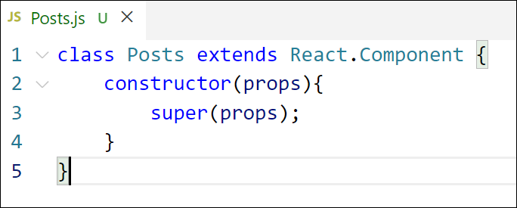

Figure 3: Posts Component

1. Initialize the component with a list of Post in state of the component using the constructor
2. Create a new method in component with the name as **loadPosts()** which will be responsible for using Fetch API and assign it to the component state created earlier. To get the posts use the url (<https://jsonplaceholder.typicode.com/posts>)

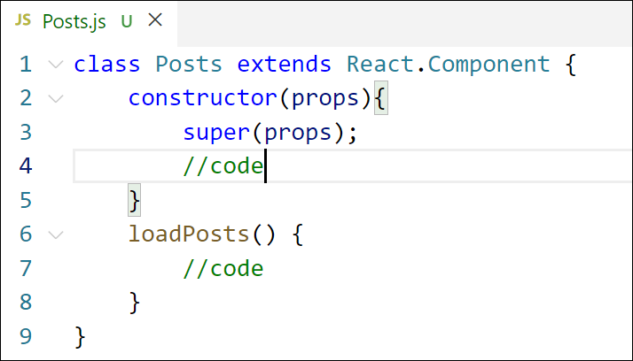

Figure 4: loadPosts() method

1. Implement the **componentDidMount()** hook to make calls to **loadPosts()** which will fetch the posts

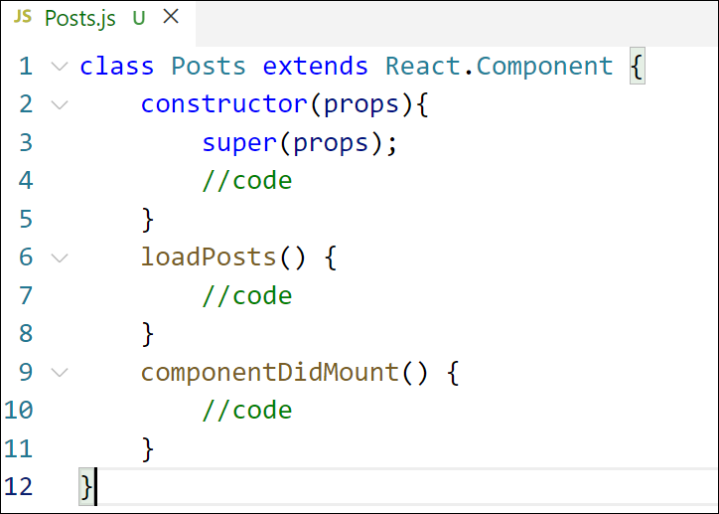

Figure 5: componentDidMount() hook

1. Implement the **render()** which will display the title and post of posts in html page using heading and paragraphs respectively.

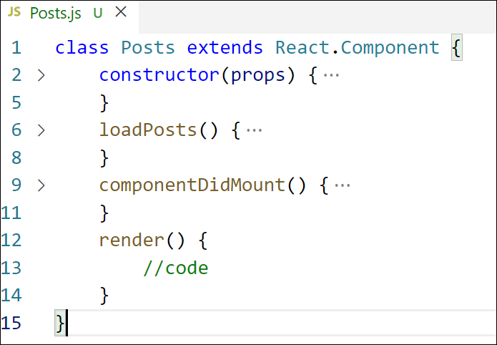

Figure 6: render() method

1. Define a **componentDidCatch()** method which will be responsible for displaying any error happing in the component as alert messages.

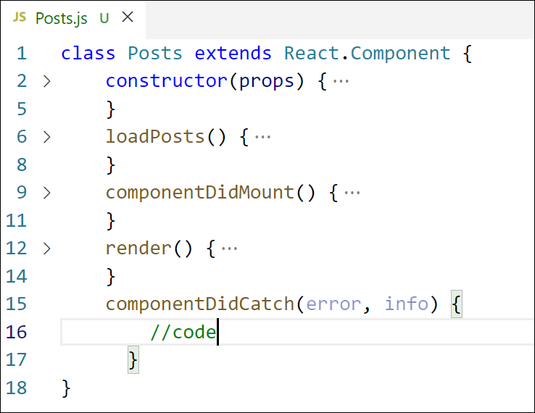

Figure 7: componentDidCatch() hook

1. Add the Posts component to App component.
2. Build and Run the application using *npm start* command.

**App.js**

// src/Posts.js

import React, { Component } from 'react';

import Post from './Post';

class Posts extends Component {

  constructor(props) {

    super(props);

    this.state = {

      posts: [],

      hasError: false,

    };

  }

  loadPosts = () => {

    fetch('https://jsonplaceholder.typicode.com/posts')

      .then(response => response.json())

      .then(data => this.setState({ posts: data }))

      .catch(error => {

        this.setState({ hasError: true });

        console.error('Error loading posts:', error);

      });

  };

  componentDidMount() {

    this.loadPosts();

  }

  componentDidCatch(error, info) {

    alert("An error occurred: " + error);

  }

  render() {

    return (

      <div>

        <h2>Blog Posts</h2>

        {this.state.posts.map(post => (

          <Post key={post.id} title={post.title} body={post.body} />

        ))}

      </div>

    );

  }

}

export default Posts;

**App.css**

.App {

  text-align: center;

}

.App-logo {

  height: 40vmin;

  pointer-events: none;

}

@media (prefers-reduced-motion: no-preference) {

  .App-logo {

    animation: App-logo-spin infinite 20s linear;

  }

}

.App-header {

  background-color: #282c34;

  min-height: 100vh;

  display: flex;

  flex-direction: column;

  align-items: center;

  justify-content: center;

  font-size: calc(10px + 2vmin);

  color: white;

}

.App-link {

  color: #61dafb;

}

@keyframes App-logo-spin {

  from {

    transform: rotate(0deg);

  }

  to {

    transform: rotate(360deg);

  }

}

**Post.js**

// src/Post.js

import React from 'react';

function Post(props) {

  return (

    <div style={{ marginBottom: '20px', borderBottom: '1px solid #ccc' }}>

      <h3>{props.title}</h3>

      <p>{props.body}</p>

    </div>

  );

}

export default Post;

**Posts.js**

// src/Posts.js

import React, { Component } from 'react';

import Post from './Post';

class Posts extends Component {

  constructor(props) {

    super(props);

    this.state = {

      posts: [],

      hasError: false,

    };

  }

  loadPosts = () => {

    fetch('https://jsonplaceholder.typicode.com/posts')

      .then(response => response.json())

      .then(data => this.setState({ posts: data }))

      .catch(error => {

        this.setState({ hasError: true });

        console.error('Error loading posts:', error);

      });

  };

  componentDidMount() {

    this.loadPosts();

  }

  componentDidCatch(error, info) {

    alert("An error occurred: " + error);

  }

  render() {

    return (

      <div>

        <h2>Blog Posts</h2>

        {this.state.posts.map(post => (

          <Post key={post.id} title={post.title} body={post.body} />

        ))}

      </div>

    );

  }

}

export default Posts;

